1. 
2. There are concurrency hazards such as **Race-Condition**.
3. **Race-Condition**:
   1. When same object is shared among multiple threads and that object’s state is modified by the threads.
4. **Scenario**:
   1. John & Anita have joint account with balance 100$.
   2. 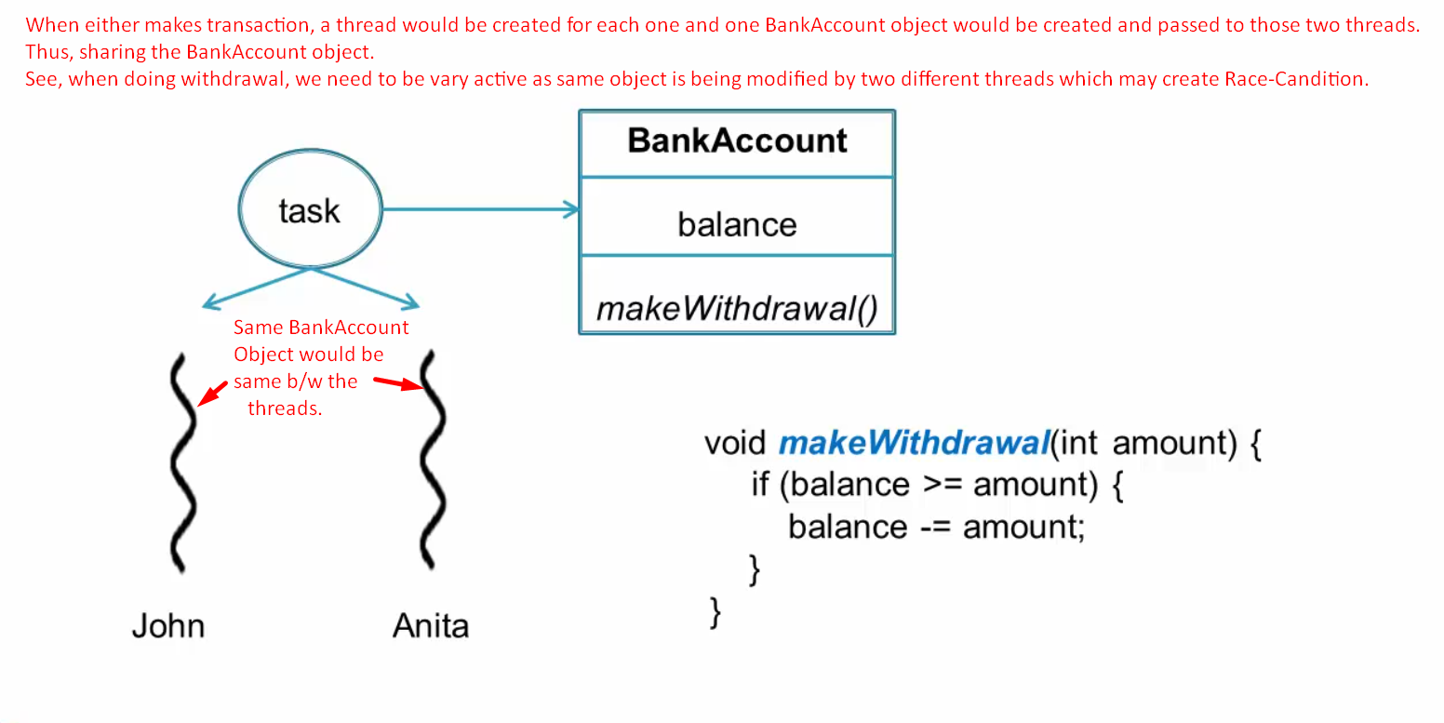
   3. 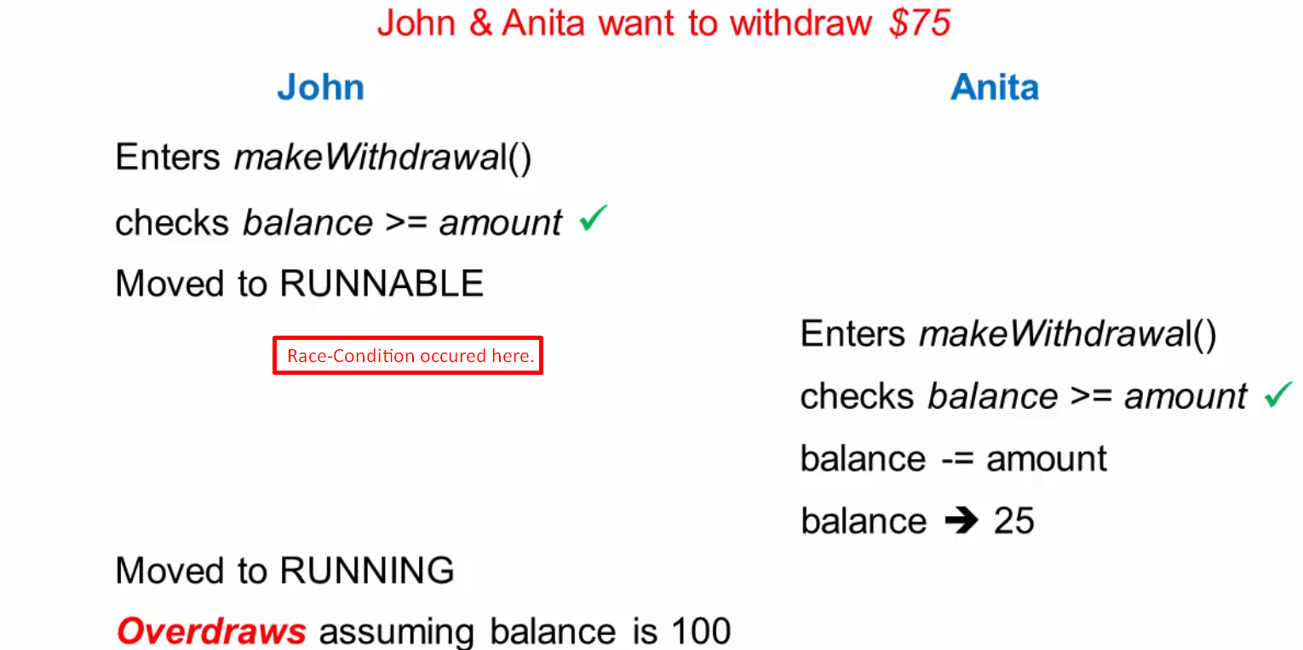
   4. 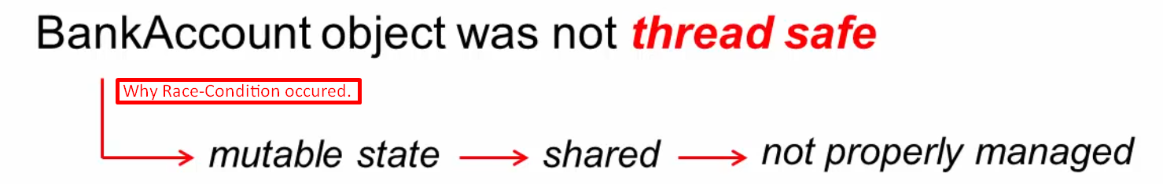
   5. 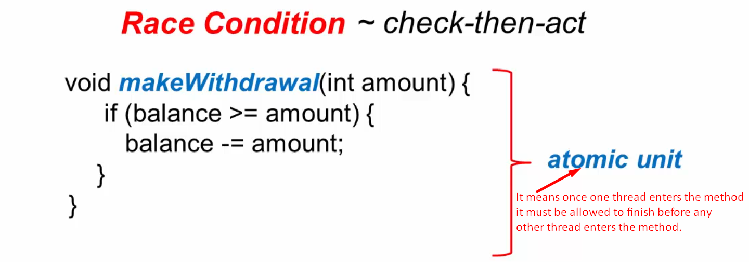
   6. 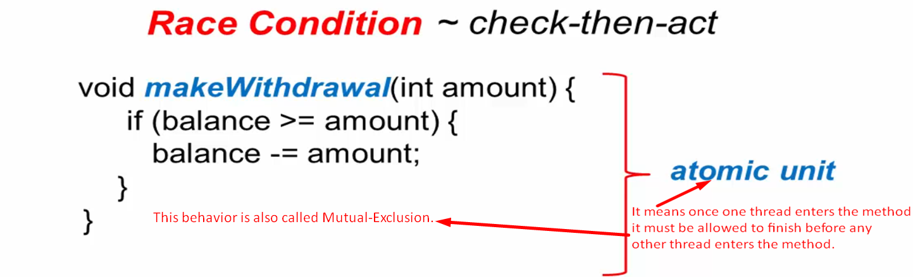
   7. 
   8. 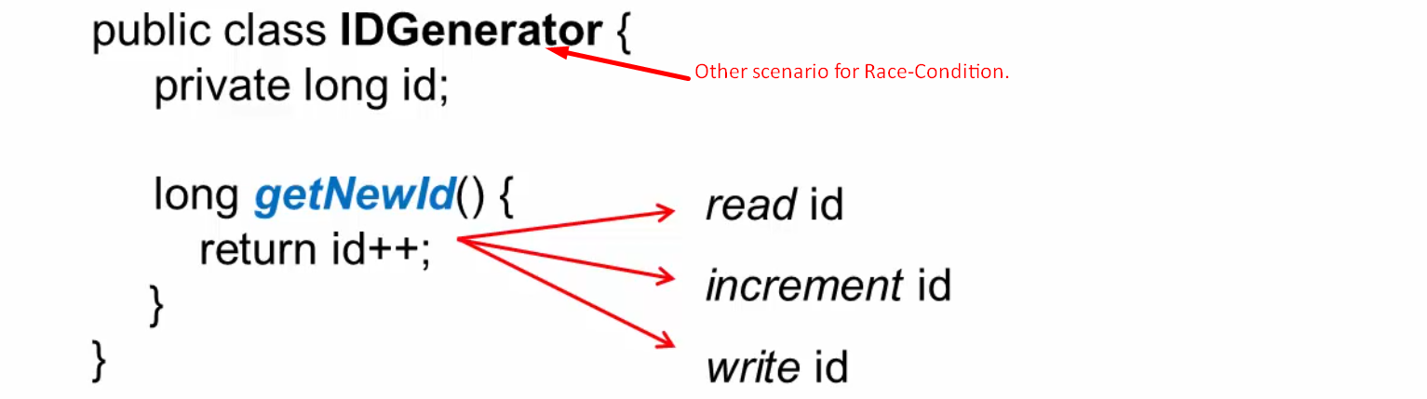
5. Scenario where Join Account is debited by two different threads at the same time thus Race-Condition  
   